# Build instructions for a gravity powered unidirectional stepper motor

INCOMPLETE

Will Stevens 2016-09-10

## 3D printed components

These can be obtained from the relayraprap repository in GitHub: <https://github.com/WillStevens/relayreprap/tree/master/gravitymotor3>

### Cog

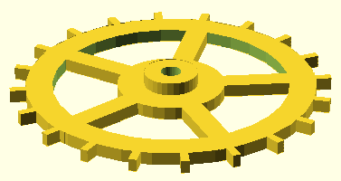

### Releaser

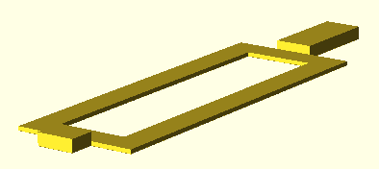

### Mount

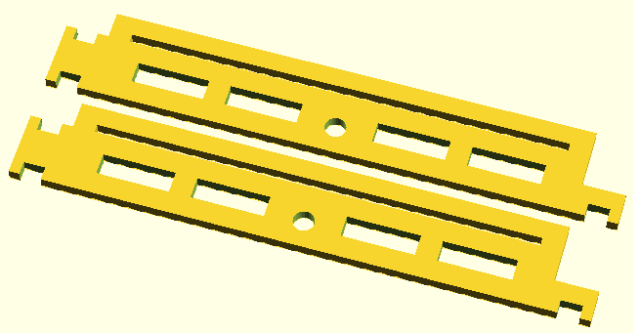

### Solenoid

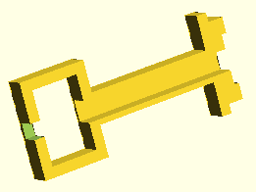

### Spool

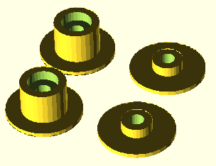

### Joiner



## Other components

70mm length of 3.8mm diameter steel rod. A sawn-off tent peg can be used.

A 30mm galvanized iron felt nail

Approx 50m of 34 swg enamled copper wire.

Quick set epoxy adhesive.

Thread.

Two weights.

## Estimated cost of components

PLA plastic = £0.50

70mm length of 3.8mm diameter steel rod = £0.10

30mm iron nail = £0.02

50m 34 swg enameled copper wire = £0.50

Epoxy adhesive = £0.10

Thread = £0.05

Weights = £0.05

Total = £1.32

## Tools needed

Hand drill

A second nail

Small magnet

Sticky tac

## Assembly instructions

### Solenoid

Place the 30mm nail inside the plastic part of the solenoid. Put the second nail inside the drill chuck, and slot it into the slot in the base of the plastic part of the solenoid. Use the magnet to stick the two nails together, and use the sticky tac to stick the nail that is in the drill chuck to the base of the plastic part of the solenoid.

Wind 1300 turns of 34 swg enameled copper wire around the solenoid former. On the drill I used, one turn of the handle resulted in 4.3 turns of the chuck, so I turned the handle 300 times to get 1290 turns of wire.

## The finished motor